Movie Theater Ticketing System

Software Requirements and Design Specification

2.0

07/22/2026

Group 7
Kebron Tadesse
Omar Kassim
Aidan Delgadillo

Prepared for
CS 250- Introduction to Software Systems
Instructor: Gus Hanna, Ph.D.
Summer 2026

Revision History

Date | Description | Author | Comments
July 11, 2026 | Version 1.0 | Kebron | Initial SRS
July 20, 2026 | Version 2.0 | Kebron | Added Section 6: Software Design

Document Approval

The following Software Requirements Specification has been accepted and approved by the following:
Signature | Printed Name | Title | Date
 | Kebron Tadesse | Software Eng. | July 11,2026
 | Kebron Tadesse | Software Eng. | July 20,2026
 | Dr. Gus Hanna | Instructor, CS 250

Table of Contents
Revision History ii
Document Approval ii
1. Introduction 1
1.1 Purpose 1
1.2 Scope 1
1.3 Definitions, Acronyms, and Abbreviations 1
1.4 References 1
1.5 Overview 1
2. General Description 2
2.1 Product Perspective 2
2.2 Product Functions 2
2.3 User Characteristics 2
2.4 General Constraints 2
2.5 Assumptions and Dependencies 2
3. Specific Requirements 2
3.1 External Interface Requirements 3
3.1.1 User Interfaces 3
3.1.2 Hardware Interfaces 3
3.1.3 Software Interfaces 3
3.1.4 Communications Interfaces 3
3.2 Functional Requirements 3
3.2.1 <Functional Requirement or Feature #1> 3
3.2.2 <Functional Requirement or Feature #2> 3
3.3 Use Cases 3
3.3.1 Use Case #1 3
3.3.2 Use Case #2 3
3.4 Classes / Objects 3
3.4.1 <Class / Object #1> 3
3.4.2 <Class / Object #2> 3
3.5 Non-Functional Requirements 4
3.5.1 Performance 4
3.5.2 Reliability 4
3.5.3 Availability 4
3.5.4 Security 4
3.5.5 Maintainability 4
3.5.6 Portability 4
3.6 Inverse Requirements 4
3.7 Design Constraints 4
3.8 Logical Database Requirements 4
3.9 Other Requirements 4
4. Analysis Models 4
4.1 Sequence Diagrams 5
4.3 Data Flow Diagrams (DFD) 5
4.2 State-Transition Diagrams (STD) 5
5. Change Management Process 5
6. SOFTWARE DESIGN ...............................................................................................................................................................10
6.1 SYSTEM DESCRIPTION .......................................................................................................................................................11
6.2 SOFTWARE ARCHITECTURE OVERVIEW ...................................................................................................................12
6.3 UML CLASS DIAGRAM ............................................................................................................................................... 12
6.4 DEVELOPMENT PLAN AND TIMELINE .....................................................................................................................13
A. Appendices 5
A.1 Appendix 1 5
A.2 Appendix 2 5

1. Introduction

The Movie Theater Ticketing System is a web-based application designed to simplify the process of purchasing and managing movie tickets across a chain of theaters in the San Diego area. The system provides customers with an efficient way to browse movies, view showtimes, reserve seats, purchase tickets, and manage their bookings through a standard web browser. It also provides theater administrators with tools to manage movies, showtimes, pricing, and ticket availability from a centralized system.

This Software Requirements Specification (SRS) defines the functional and non-functional requirements of the Movie Theater Ticketing System. The document serves as the foundation for the design, implementation, testing, and maintenance of the software throughout the project lifecycle.

1.1 Purpose

The purpose of this Software Requirements Specification (SRS) is to define the requirements for the Movie Theater Ticketing System. It describes the system's functionality, performance expectations, user interactions, and operational constraints to ensure that developers, testers, project managers, and stakeholders share a common understanding of the software before implementation begins.

This document will serve as the primary reference for designing, developing, testing, and maintaining the system throughout the project.

1.2 Scope

The Movie Theater Ticketing System is a browser-based application that enables customers to purchase movie tickets online for participating theaters located throughout San Diego County. The system supports live ticket availability across all theaters using a centralized database, ensuring that customers always view current movie schedules and seat availability.

The system allows customers to browse movies, view showtimes, purchase up to twenty tickets per transaction, reserve seats, apply eligible discounts, purchase loyalty memberships, and securely complete online payments. After each completed purchase, customers may provide feedback regarding their experience.

The system also provides an administrator interface that allows authorized personnel to manage movies, showtimes, ticket prices, theater information, and customer reservations. Administrative changes are reflected immediately throughout the system.

The system will not process in-person refunds, as refunds will be handled directly by theater employees.

1.3 Definitions, Acronyms, and Abbreviations
Term | Definition
Administrator | Authorized theater employee who manages movies, showtimes, pricing, and system operations.
Customer | Individual who uses the system to purchase or manage movie tickets.
Deluxe Theater | Theater containing assigned premium seating.
Regular Theater | Theater offering general admission seating.
Loyalty Membership | Membership program that allows customers to earn benefits and reserve tickets.
Showtimes | Scheduled dates and times when a movie is screened.
SRS | Software Requirements Specification.
UI | User Interface.

1.4 References

CS 250 Software Requirements Specification Template.

CS 250 Client Interview Notes – Movie Theater Ticketing System.

CS 250 Lecture Notes – Use Cases.

IEEE Recommended Practice for Software Requirements Specifications (IEEE 830).1.5 Overview

This Software Requirements Specification is organized into sections describing the overall system, functional requirements, external interfaces, use cases, and non-functional requirements for the Movie Theater Ticketing System. Future revisions of this document will include additional design artifacts such as analysis models, database requirements, and system diagrams as the project progresses.

2. General Description

2.1 Product Perspective

The Movie Theater Ticketing System is an independent, web-based platform designed to centralize and manage ticket sales for a chain of participating theaters in San Diego County. It acts as the primary customer-facing interface for online bookings and the administrative backend for theater management, replacing localized or manual ticketing processes with a unified, real-time system.

2.2 Product Functions

- Customer Functions: Browse movies and current showtimes, reserve specific seats (regular and deluxe), purchase up to twenty tickets per transaction, purchase and utilize loyalty memberships, apply eligible discounts, process secure online payments, and submit post-purchase feedback.

- Administrator Functions: Add and manage movie listings, update showtimes, adjust ticket pricing, modify theater information, and monitor customer reservations.

2.3 User Characteristics

Customers: The general public spanning a wide range of ages and technical proficiencies. Because of this, the system requires a highly intuitive, easy-to-navigate user interface that guides them seamlessly from browsing to checkout.

Administrators: Authorized theater employees and managers. They are assumed to have basic computer literacy and will receive specific training on how to navigate the system's administrative dashboard.

2.4 General Constraints

The system is strictly a web-based application and must not require users to download or install proprietary software. It must operate using a centralized database to ensure ticket availability is updated in real-time across all locations, preventing concurrent double-bookings. Furthermore, the software is constrained from processing customer refunds online; all refund actions are restricted to in-person transactions handled directly by theater employee

2.5 Assumptions and Dependencies

Assumptions: It is assumed that customers and theater administrators have reliable internet access and utilize modern, updated web browsers. It is also assumed that participating theaters possess the necessary physical hardware (e.g., barcode scanners or mobile devices) to validate digital tickets on-site.

Dependencies: The system depends heavily on a secure, third-party payment gateway integration to process credit card transactions safely and comply with online payment standards. It also relies on a high-availability server infrastructure to host the centralized database and maintain uninterrupted 24/7 synchronization across all theater locations.

3. Specific Requirements

3.1 External Interface Requirements
This section defines how the Movie Theater Ticketing System will interact with external users, hardware devices, software systems, and network protocols to ensure secure and reliable operation.

3.1.1 User Interfaces
Customer Interface: A responsive web interface accessible via standard desktop and mobile browsers. It shall include clear navigation for browsing movie titles, an interactive visual map for seat selection, a checkout screen for payment processing, and a final confirmation page displaying the digital ticket.

Administrator Interface: A secure backend dashboard accessible only via authorized login credentials. It shall feature data entry forms for managing movie schedules, input fields for adjusting ticket pricing, and real-time viewing portals for monitoring theater capacity and sales.

Error Prompts: The interface must display clear, non-technical error messages to users if a transaction fails, a session times out, or a requested seat becomes unavailable during checkout.

3.1.2 Hardware Interfaces
Client Devices: The system shall operate efficiently on standard consumer hardware, including PCs, laptops, tablets, and smartphones, utilizing their native displays and input methods (mouse, keyboard, touchscreen).

Theater Ticket Scanners: The system must generate digital tickets containing standard 2D barcodes or QR codes. These codes must be formatted to be actively read and validated by the physical optical scanners used by theater employees at the auditorium entrances.

3.1.3 Software Interfaces
Centralized Database: The application shall interface with a central relational database to read and write live data. This ensures that showtimes, ticket prices, and seat availability maps are instantly synchronized across all participating San Diego theater locations.

Third-Party Payment Gateway: The system shall integrate with an external payment processing API (e.g., Stripe, PayPal, or Square) to authorize and capture credit card transactions securely. The system will rely entirely on this interface for processing to avoid storing sensitive financial data on local servers.

3.1.4 Communications Interfaces
Secure Network Protocols: All data transmission between the client web browser, the web server, and the centralized database must be encrypted using HTTPS (Hypertext Transfer Protocol Secure) with standard TLS protocols to protect user credentials and session data.

Email Notification Gateway: The system shall connect to a standard SMTP (Simple Mail Transfer Protocol) server to automatically generate and dispatch purchase receipts and digital ticket links to the customer's provided email address immediately following a successful transaction.

3.2 Functional Requirements
This section describes specific features of the software project. If desired, some requirements may be specified in the use-case format and listed in the Use Cases Section.
3.2.1 Process Ticket Purchase

3.2.1.1 Introduction: The system shall allow customers to select movies, reserve seats, and purchase up to twenty tickets per transaction.

3.2.1.2 Inputs: Movie selection, showtime, seat selection, and payment credentials.

3.2.1.3 Processing: The system will validate live seat availability, calculate the total cost, process the payment, and reserve the requested seats.

3.2.1.4 Outputs: A booking confirmation number, digital tickets, and an itemized receipt.

3.2.1.5 Error Handling: If the payment fails or seats are taken concurrently by another user, the system will release the local hold on the seats and notify the user to restart the transaction.

3.2.2 Manage Administrator Dashboard

3.2.2.1 Introduction: The system shall provide a secure backend interface for authorized theater employees to manage daily operations.

3.2.2.2 Inputs: Administrator login credentials, new movie titles, showtime schedules, and ticket pricing adjustments.

3.2.2.3 Processing: The system will authenticate the user, commit the operational updates to the centralized database, and push the changes live.

3.2.2.4 Outputs: Real-time updates to the customer-facing interface reflecting the newly adjusted schedules or prices.

3.2.2.5 Error Handling: If database synchronization fails, the system will alert the administrator and automatically revert to the last saved state.

3.3 Use Cases

3.3.1 Use Case #1: Purchase Movie Tickets
Actor: Customer
Main Flow: The customer selects a movie, chooses seats from the live map, enters payment information, and receives digital tickets.
Alternative Flow: If the payment is declined, the system pauses the reservation for 5 minutes and prompts for a different payment method.
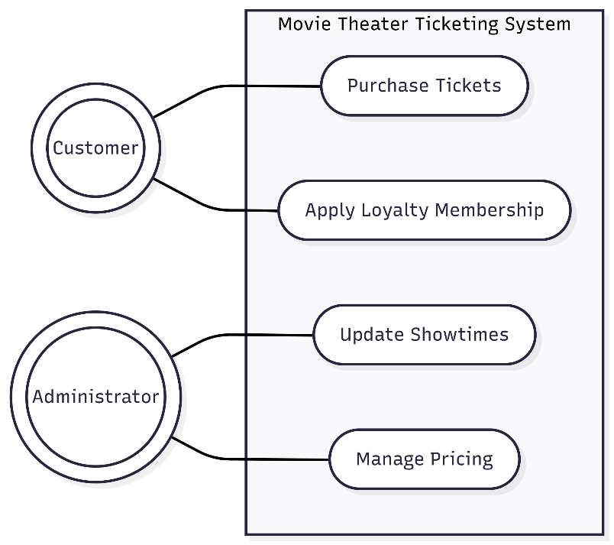

3.3.2 Use Case #2: Apply Loyalty Membership

Actor: Customer

Main Flow: The customer logs into their loyalty account during checkout, and the system automatically applies the corresponding membership discount to their ticket total.
3.3.3 Use Case #3: Update Showtimes
Actor: Administrator
Main Flow: The administrator logs into the backend dashboard, selects a specific theater, updates the movie schedules, and publishes the changes to the live database.
3.4 Classes / Objects
3.4.1 Customer
3.4.1.1 Attributes
customerID (String)
emailAddress (String)
loyaltyStatus (Boolean)
3.4.1.2 Functions
initiatePurchase()
applyDiscount()
References: Functional Requirement 3.2.1, Use Cases 3.3.1 and 3.3.2.

3.4.2 Ticket
3.4.2.1 Attributes
ticketID (String)

seatNumber (String)

price (Float)

movieShowtime (DateTime)

3.4.2.2 Functions

generateDigitalBarcode()

reserveSeat()

References: Functional Requirement 3.2.1, Use Case 3.3.1.

3.5 Non-Functional Requirements

3.5.1 Performance
The system shall process ticket transactions and update live seat availability in under 2 seconds to prevent concurrent double-booking during high-traffic movie premieres.

3.5.2 Reliability
The system shall ensure zero transaction data loss in the event of a client-side browser crash, guaranteeing session recovery within 5 minutes of a localized server failure.

3.5.3 Availability
The ticketing web application shall maintain 99.9% uptime, ensuring the customer-facing interface is accessible 24 hours a day, 7 days a week.

3.5.4 Security
All customer payment processing shall strictly comply with PCI DSS standards. Additionally, all administrator passwords must be encrypted in the database using standard SHA-256 hashing algorithms.

3.5.5 Maintainability
The system's database architecture shall allow administrators to deploy regular software updates or add new participating theater locations with less than 30 minutes of scheduled system downtime.

3.5.6 Portability
The web application shall be fully operational, responsive, and visually consistent on current versions of Chrome, Safari, Firefox, and Edge across both desktop and mobile operating systems.

3.6 Inverse Requirements
The system shall not allow the selection or purchase of seats that are currently held in an active, unexpired checkout session by another user.

The system shall not process ticket cancellations, exchanges, or financial refunds online; all such actions are strictly restricted to physical point-of-sale terminals managed by theater staff..

3.7 Design Constraints

The application's digital ticket outputs must be visually formatted and scaled to be universally readable by the existing optical 2D barcode scanners utilized at the physical theater checkpoints. Additionally, the system must not require end-users to install proprietary software or plugins, strictly limiting the client-side architecture to standard web browsers.

3.8 Logical Database Requirements

The ticketing system will utilize a centralized relational database to strictly enforce ACID (Atomicity, Consistency, Isolation, Durability) properties, preventing data corruption during concurrent high-volume transactions. The database must securely retain customer purchase history, loyalty point ledgers, and itemized transaction receipts for a minimum of three years to support financial auditing.

3.9 Other Requirements
(No additional requirements at this time).

4. Analysis Models
List all analysis models used in developing specific requirements previously given in this SRS. Each model should include an introduction and a narrative description. Furthermore, each model should be traceable the SRS’s requirements.

4.1 Sequence Diagrams

4.3 Data Flow Diagrams (DFD)

4.2 State-Transition Diagrams (STD)

5. Change Management Process
Identify and describe the process that will be used to update the SRS, as needed, when project scope or requirements change. Who can submit changes and by what means, and how will these changes be approved.

6. Software Design

6.1 System Description
The Movie Theater Ticketing System is a centralized, web-based application designed to facilitate online ticket purchasing for customers and streamline operations for theater administrators. Customers can seamlessly browse current movie schedules, reserve specific seats, apply loyalty discounts, and process payments securely. The system operates on a live database to ensure seat availability is synchronized in real-time, preventing double-bookings. Administrators utilize a secure backend interface to manage movie showtimes, adjust ticket pricing, and monitor active reservations.

6.2 Software Architecture Overview

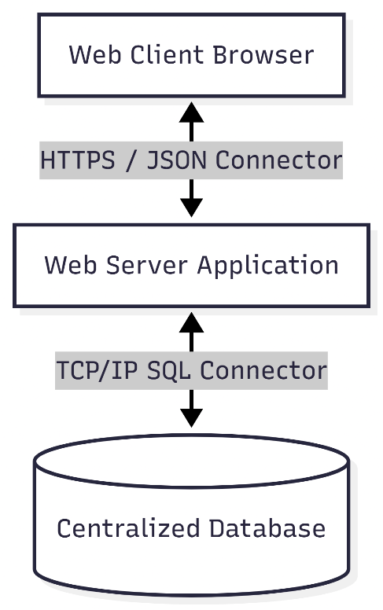
Architecture Description: The system utilizes a standard Client-Server Architecture following a Model-View-Controller (MVC) design pattern to cleanly separate the user interface from the backend logic and database.
Web Client (Frontend Component): The user-facing component running in standard web browsers. It renders the responsive HTML/CSS/JavaScript interfaces for both the Customer ticketing portal and the Administrator management dashboard.
Web Server (Backend Component): The core application logic layer handling HTTP requests, user authentication, payment gateway processing, and business rules.
Database (Storage Component): A centralized relational database storing all persistent system data, including user profiles, movie schedules, seat availability maps, and itemized transaction records.
Connectors: The Web Client and Web Server components communicate bidirectionally via secure HTTPS / JSON over the internet. The Web Server and Database components communicate utilizing standard TCP/IP SQL protocols to ensure rapid, secure data querying and synchronization.

6.3 UML Class Diagram

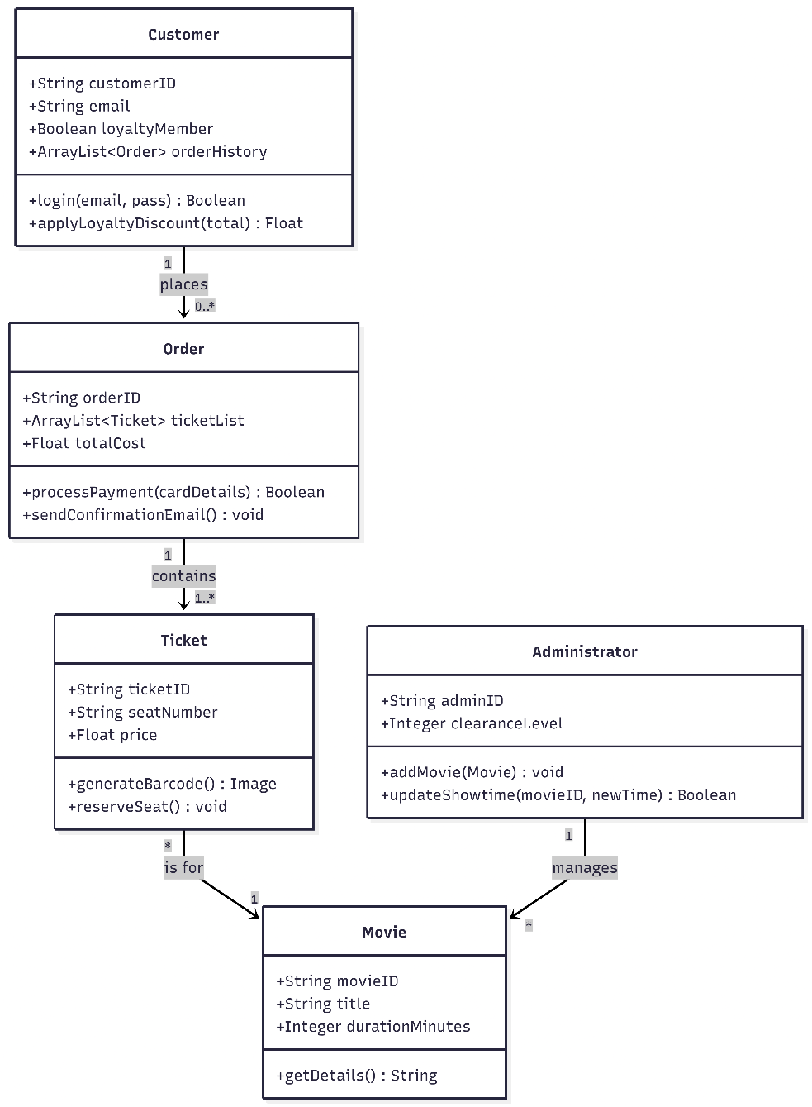

6.3.1 Customer
- Description: Represents a standard user interacting with the ticketing system to purchase tickets.
- Attributes:
  - customerID: String - Unique identifier for the customer.
  - email: String - Customer's contact email.
  - loyaltyMember: Boolean - Flag indicating if they have an active loyalty membership.
  - orderHistory: ArrayList<Order> - A dynamic list storing the customer's past purchases.
- Operations:
  - login(email: String, pass: String): Boolean - Authenticates the user.
  - applyLoyaltyDiscount(total: Float): Float - Calculates the new price if loyaltyMember is true.
6.3.2 Administrator
- Description: Represents an authorized theater employee with elevated privileges to manage the system.
- Attributes:
  - adminID: String - Unique identifier for the employee.
  - clearanceLevel: Integer - Determines access rights within the dashboard.
- Operations:
  - addMovie(m: Movie): void - Inserts a new movie into the system database.
  - updateShowtime(movieID: String, newTime: DateTime): Boolean - Modifies existing schedules.
6.3.3 Movie
- Description: Represents a film being shown at the theater.
- Attributes:
  - movieID: String - Unique identifier.
  - title: String - The name of the film.
  - durationMinutes: Integer - The runtime of the film.
- Operations:
  - getDetails(): String - Returns formatted movie information.
6.3.4 Ticket
- Description: Represents a reserved seat for a specific movie showtime.
- Attributes:
  - ticketID: String - Unique barcode/identifier.
  - seatNumber: String - The specific assigned seat (e.g., "G14").
  - price: Float - The cost of the individual ticket.
- Operations:
  - generateBarcode(): Image - Creates the scannable digital asset.
  - reserveSeat(): void - Flags the seat as unavailable in the database.
6.3.5 Order
- Description: Represents a complete checkout transaction containing one or more tickets.
- Attributes:
  - orderID: String - Unique transaction number.
  - ticketList: ArrayList<Ticket> - A dynamic list of all tickets purchased in this transaction.
  - totalCost: Float - The final calculated price after taxes and discounts.
- Operations:
  - processPayment(cardDetails: String): Boolean - Interfaces with the payment gateway.
  - sendConfirmationEmail(): void - Dispatches the digital receipt.

6.4 Development Plan and Timeline

Partitioning of Tasks and Responsibilities: To ensure an organized development lifecycle and equal contribution across the repository, the engineering effort has been divided into specialized roles. Each member will lead a specific architectural domain while participating in joint code reviews.
Omar Kassim (Lead Frontend Engineer):
Tasks: Designing and implementing the responsive user interface (HTML/CSS/JS) for both the Customer Portal and Administrator Dashboard.
Responsibilities: Ensuring cross-browser compatibility, handling client-side form validation, designing the interactive seat-selection map, and consuming backend API endpoints to render dynamic movie data.
Aidan Delgadillo (Lead Backend Engineer):
Tasks: Developing the Web Server application logic utilizing the MVC pattern.
Responsibilities: Building RESTful API routes, implementing secure user authentication (hashing passwords), programming the core business logic (calculating loyalty discounts, preventing double-booking), and integrating the external payment gateway.
Kebron Tadesse (Lead Database Administrator):
Tasks: Designing and deploying the centralized relational database.
Responsibilities: Writing and optimizing SQL queries, structuring the schema to ensure strict data integrity (primary/foreign keys), managing server deployment, and setting up the connection protocols between the backend controllers and the database.

Estimated Timeline (Agile Sprints): The project will be executed over a 5-week period, structured into weekly development sprints to ensure all deliverables are met prior to the final submission deadline.

Phase | Timeframe | Development Focus | Key Deliverables
Sprint 1 | July 17 - July 23 | System Design & Planning | Finalizing Software Design Specification, defining UML/SWA diagrams, and assigning specialized developer roles.
Sprint 2 | July 24 - July 30 | Architecture & Setup | GitHub repository initialization, UI wireframing complete, and relational database schema creation.
Sprint 3 | July 31 - Aug 6 | Core Implementation | Frontend static views finalized. Backend API routes mapped and connected to the database.
Sprint 4 | Aug 7 - Aug 13 | Integration & Logic | Dynamic data rendering via API, interactive seat selection active, and payment gateway sandbox testing.
Sprint 5 | Aug 14 - Aug 20 | Testing & Deployment | End-to-end system integration, bug fixing, QA testing, and final deployment of the application.

A. Appendices
Appendices may be used to provide additional (and hopefully helpful) information. If present, the SRS should explicitly state whether the information contained within an appendix is to be considered as a part of the SRS’s overall set of requirements.

Example Appendices could include (initial) conceptual documents for the software project, marketing materials, minutes of meetings with the customer(s), etc.

A.1 Appendix 1

A.2 Appendix 2

